Q1) Write a java program to create a class called “Employee” with name , salary and hire date attributes and a method to calculate years of service.

import java.time.LocalDate;

import java.time.Period;

import java.util.Scanner;

class Employee {

    private String name;

    private int salary;

    private int year;

    private int month;

    private int date;

    Employee(String name, int salary, int year, int month, int date) {

        this.name = name;

        this.salary = salary;

        this.year = year;

        this.month = month;

        this.date = date;

    }

    public void yearOfServices() {

        Scanner sc = new Scanner(System.in);

        System.out.print("Enter the end year (YYYY): ");

        int endYear = sc.nextInt();

        System.out.print("Enter the end month (MM): ");

        int endMonth = sc.nextInt();

        System.out.print("Enter the end day (DD): ");

        int endDay = sc.nextInt();

        LocalDate hireDate = LocalDate.of(year, month, date);

        LocalDate endDate = LocalDate.of(endYear, endMonth, endDay);

        Period differPeriod = Period.between(hireDate, endDate);

        int yearsOfService = differPeriod.getYears();

        System.out.println("Years of Service: " + yearsOfService + " years");

    }

}

public class que_1 {

    public static void main(String[] args) {

        Scanner sc = new Scanner(System.in);

        System.out.print("Enter the number of test cases: ");

        int test = sc.nextInt();

        sc.nextLine();

        for (int i = 0; i < test; i++) {

            System.out.print("Enter the name of the employee: ");

            String name = sc.nextLine();

            System.out.print("Enter the salary: ");

            int salary = sc.nextInt();

            System.out.print("Enter hire year (YYYY): ");

            int hireYear = sc.nextInt();

            System.out.print("Enter hire month (MM): ");

            int hireMonth = sc.nextInt();

            System.out.print("Enter hire day (DD): ");

            int hireDay = sc.nextInt();

            sc.nextLine();

            Employee e = new Employee(name, salary, hireYear, hireMonth, hireDay);

            e.yearOfServices();

        }

        sc.close();

    }

}

OUTPUT:

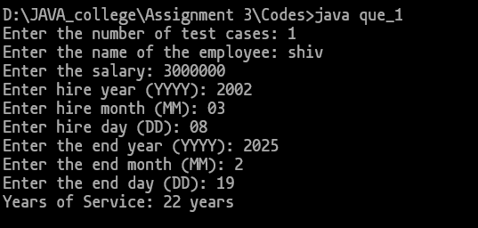

Q2) Write a java program to create a class called “Rectangle” with attributes height and width. Calculate the area and perameter of rectangle.

import java.util.Scanner;

class rectangle{

    private  double height;

    private  double width;

    rectangle(double height, double  width){

        this.height = height;

        this.width = width;

    }

    public void area(){

        System.out.println("Area: " + (this.height * this.width));

    }

    public void perimeter(){

        System.out.println("Perimeter: " + (2 * (this.height + this.width)));

    }

}

public class que_2 {

    public static void main(String[] args) {

        Scanner sc = new Scanner(System.in);

        System.out.print("Enter the number of test cases: ");

        int test = sc.nextInt();

        sc.nextLine();

        for (int i = 0; i < test; i++) {

            System.out.print("Enter the height: ");

            double h = sc.nextDouble();

            System.out.print("Enter the width: ");

            double w = sc.nextDouble();

            rectangle r = new rectangle(h, w);

            r.area();

            r.perimeter();

            System.out.println(" ");

        }

    }

}

OUTPUT:

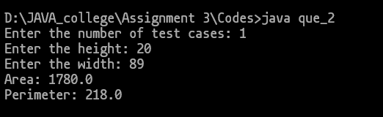

Q3) Write a java program to create a base class shape with a method called calculateArea().create three subclasses : Circle , Rectangle and Triangle . override the calculateArea() method in each subclass to calculate and print the shape’s area.

import java.util.Scanner;

class Base{

    public void calculateArea(){

        System.out.println("This is the base class");

    }

}

class Circle extends  Base{

    private  double  radius;

    Circle(double radius){

        this.radius = radius;

    }

    @**Override**

    public  void calculateArea(){

        System.out.println("Area: " + (3.14 * this.radius * this.radius));

    }

}

class Triangle extends Base{

    private double breadth;

    private  double height;

    Triangle(double b, double h) {

        this.breadth = b;

        this.height =h;

    }

    @**Override**

    public void calculateArea(){

        System.out.println(("Area: " + ((double) 1 / 2 * this.breadth * this.height)));

    }

}

class Rectanglee extends Base{

    private final double height;

    private final double width;

    Rectanglee(double h, double  w){

        this.height = h;

        this.width = w;

    }

    @**Override**

    public void calculateArea(){

        System.out.println("Area: " + (this.height * this.width));

    }

}

public class que_3 {

    public static void main(String[] args) {

        Scanner sc = new Scanner(System.in);

        System.out.print("Enter the number of test cases: ");

        int test = sc.nextInt();

        sc.nextLine();

        for (int i = 0; i < test; i++) {

            System.out.println("Enter the shape number\n 1. Circle\n 2.Rectangle\n 3.Triangle");

            int flag = sc.nextInt();

            switch (flag) {

                case 1:

                    System.out.print("Enter radius of circle: ");

                    double r = sc.nextDouble();

                    Circle c = new  Circle(r);

                    c.calculateArea();

                    System.out.println();

                    break;

                case 2:

                    System.out.print("Enter length: ");

                    double l = sc.nextDouble();

                    System.out.print("Enter breadth: ");

                    double b = sc.nextDouble();

                    Rectanglee rec = new Rectanglee(l, b);

                    rec.calculateArea();

                    System.out.println();

                    break;

                case 3:

                    System.out.print("Enter length: ");

                    double le = sc.nextDouble();

                    System.out.print("Enter height: ");

                    double hei = sc.nextDouble();

                    Triangle tri = new Triangle(le, hei);

                    tri.calculateArea();

                    System.out.println();

                    break;

            }

        }

    }

}

OUTPUT:

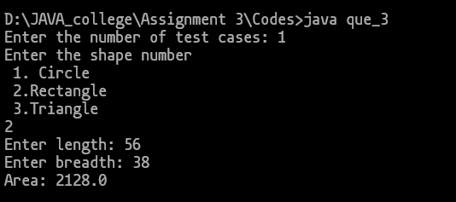

Q4) Wite a java program to create a class called Employee with methods called work() and getSalary().Create a subclass called hRManager that overrides the work() method and adds a new method called addEmployee().

import java.util.Scanner;

class Emmployee {

    private double salary;

    public Emmployee(double salary) {

        this.salary = salary;

    }

    public void work() {

        System.out.println("Employee is working.");

    }

    public double getSalary() {

        return salary;

    }

}

class HRManager extends Emmployee {

    public HRManager(double salary) {

        super(salary);

    }

    @**Override**

    public void work() {

        System.out.println("HR Manager is managing employees.");

    }

    public void addEmployee() {

        System.out.println("HR Manager is adding a new employee.");

    }

}

public class que_4 {

    public static void main(String[] args) {

        Scanner sc = new Scanner(System.in);

        System.out.print("Enter the number of test cases: ");

        int test = sc.nextInt();

        sc.nextLine();

        for (int i = 0; i < test; i++) {

            System.out.print("Enter the salary: ");

            long sal = sc.nextLong();

            HRManager hr = new HRManager(sal);

            hr.work();

            hr.addEmployee();

            System.out.println("Salary: " + hr.getSalary());

        }

    }

}

OUTPUT:

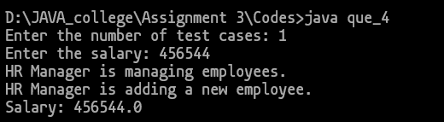

Q5) Write a program to create a class called Calc and add the methods multiply(int , int) , multiply(float, float),multiply(int , int, float) with showing the respective output of the methods.

class Calc {

    public void multiply(int a, int b) {

        int result = a * b;

        System.out.println("Multiplication of two integers: " + result);

    }

    public void multiply(float a, float b) {

        float result = a * b;

        System.out.println("Multiplication of two floats: " + result);

    }

    public void multiply(int a, int b, float c) {

        float result = (a * b) * c;

        System.out.println("Multiplication of two integers and a float: " + result);

    }

}

public class que_5{

    public static void main(String[] args) {

        Calc calculator = new Calc();

        System.out.println("Int, Int");

        calculator.multiply(5, 4);

        System.out.println("Float, Float");

        calculator.multiply(3.5f, 2.2f);

        System.out.println("Int, Int, Float");

        calculator.multiply(2, 3, 1.5f);

    }

}

OUTPUT:

